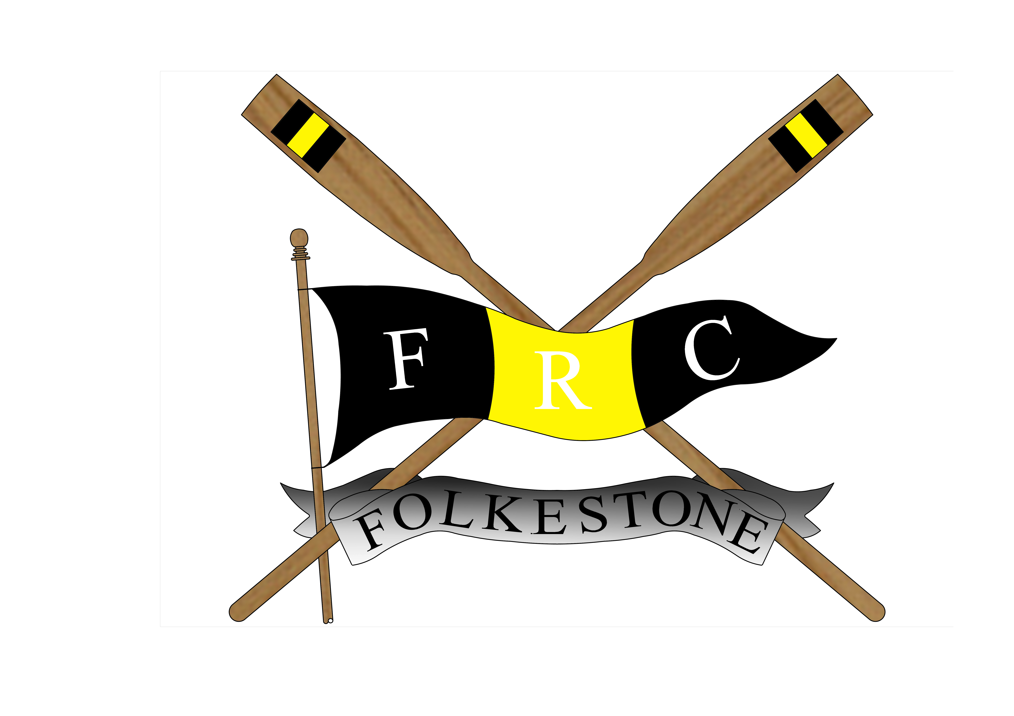
Folkestone Rowing Club
ROWING MEMBERSHIP FORM

PLEASE COMPLETE BOTH SIDES OF THIS FORM

We are pleased to welcome you to Folkestone Rowing Club

To ensure that we have the correct contact details for you, please insert the information requested below and overleaf and return this form to the Club Secretary. If you are under 16yrs please also ask your parents or guardian to sign the form before it is returned. We will also use this information to ensure that you are kept informed about club events.

Surname:
Forename:
Address:
Post Code: |  | Date of Birth
Home Telephone No. |  | Mobile:
E-Mail address:
School: |  | Gender: | Male □  Female □
Are you participating in the National Junior Rowing Programme –
Project Oarsome: Yes □ No□
ARA Membership No | (if applicable)

MEMBERSHIP TYPE
(Junior members are under 18yrs on 1st January – full membership will be due from the 1st of January following your 18th birthday).

JUNIOR □ 1-off payment £50.00 OR D/D £5 per month x 12 months □
ADULT □ 1off payment £100.00 (Over 18yrs unless in full-time education) OR
D/D £10 per month x 12 months □

Coxswain only *(non-rowing) □ FOC – Coxing only

I apply for membership of FOLKESTONE ROWING CLUB and do agree to abide by the constitution and by-laws of the club, including the water safety rules, and any amendments made thereto by those empowered, and enclose with this application the appropriate subscription.

I declare that I can swim at least 100 metres and in the event of my not being able to swim this distance I do not hold the club responsible for any accident which may occur through my inability to swim.

SIGNATURE OF APPLICANT …………………………………….

SIGNATURE OF PARENT OR GUARDIAN
IF APPLICANT UNDER 16YRS. ………………………………………

Please do not write below this line

DATE ACCEPTED | / / | SECRETARY SIGNATURE
Copy to Rowing Secretary |  | CAPTAIN’S SIGNATURE

SPORTING INFORMATION – PLEASE COMPLETE

Have you tried Rowing before? ……………………Yes □ No □

(If yes, where have you rowed before?)
School ……………………………………..□ Club ………………………….□
Local Authority coaching session(s) ………….□
Other (please specify)

…………………………………………………………………………………………………………..

MEDICAL INFORMATION

Do you consider yourself to have a disability? ……. Yes □ No □
If yes, what is the nature of your disability?

………………………………………………………………………………………………………….

………………………………………………………………………………………………………….

Do you have any medical or physical condition
Precluding heavy exercise?................. Yes □ No □

Please detail below any important medical information that our coaches/junior co-ordinator should be aware of (eg epilepsy, diabetes etc).

………………………………………………………………………………………………………….

………………………………………………………………………………………………………….

Are you / is your child currently taking any form of mediation that relates to the above ………………

……………………………………………………………………………………………………………

EMERGENCY CONTACT DETAILS – TO BE COMPLETED BY PARENT / GUARDIAN

Please insert the information below to indicate the person(s) who should be contacted in the event of any incident / accident:

Contact name (eg parent/guardian) and relationship ……………………………………………………

Relationship …………………….. Emergency contact number: …………………………

By returning this completed form, I agree to my son / daughter / child in my care taking part in the activities of the Club. I understand that I will be kept informed of these activities – for example timing and transport details. I understand that in the event of any injury or illness all reasonable steps will be taken to contact me, and to deal with that injury / illness appropriately.

As part of our Child Welfare Procedures, we require confirmation that you agree that your child’s picture may be caught on photographic image whilst taking part in rowing activities, and may be used to publicise the Club.
Yes □ No □

Name of parent / guardian (please print) ………………………………………………

Signature of parent / guardian ……………………………… Date ……………………………..

