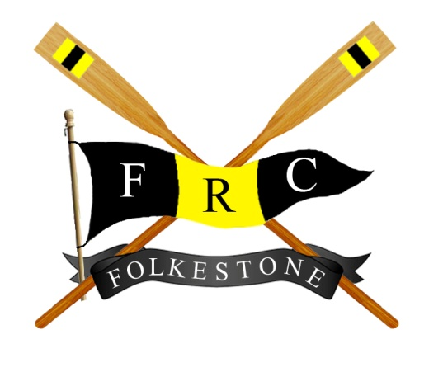
Folkestone Rowing Club COVID 19 Risk Assessment
Prepared By Peter Satchell Prepared 17 July 2020
Reviewed 27 July 2020
Reviewed 24 September 2020
Reviewed 16 May 2021

Review if Government Guidelines
Change

What are the hazards? | Who might be harmed and how? | What are we already doing to control the risk | What further actions are required to control the risks | Who will do this | When is it required by? | Done?
See last page for changes 20 September 2020

COVID 19 | Staff by contact with the virus | Staff have an awareness of the risk through normal media  Staff meeting held to remind them of the risk and to seek input to Risk Assessment  PPE has been offered to staff.  Staff briefed to wash hands on arrival and at frequent (<30min) intervals. | Brief staff not to attend work if feeling unwell.  Limit normal staff numbers to only one behind the bar. *  Install screens around bar area.  Provide hand saniters at highly frequented areas.  Provide staff training on new methods and aim to shadow staff for first shift.  Brief staff that some Members may react adversely to the new restriction, especially due to alcohol. Remind them to deal with any instances politely but firmly, and seek support from others eg Committee members or more sympathetic members as required.  Provide PPE as requested.  Prevent Member access to the long frontage of the bar to allow for a glass return route.  Reduce the range of “snacks” stocked to reduce handling. | PS/SR/TD/MV | 26/07/20 | If text is Green, it is done
COVID 19 | Members of the public and Club Members by contact with the virus | Restricting attendance to Club Members and limited guests only | Install new and more obvious “Members Only” signage.  Install hand sanitisers at entry points and high usage area such as toilets.  Install social distancing signage.  Mark Buy/Collect areas at the bar.  Arrange furniture to attain appropriate social distancing.  Prevent gathering at “bottlenecks”.  Mark a preferred entry and exit route if busy.  Mark a preferred stair route to mezzanine.  Implement a new cleaning regime.  Request Members not to move tables and to limit groups in accordance with Government Guidelines.  Request that payment be by contactless card only.  Stop the practice of “Cash Back”.  Control number and distancing by having a “seating only” policy.  Provide table cleaning facilities and ask Members to clean their table areas and chairs on arrival.  Provide a “signing in book” and advise Members to give their names and phone numbers and those of their guests.  We will follow Track and Trace protocol if informed that a person visiting has is diagnosed with Covid. This will result in us closing for at least 72 hrs.  Request that Members return their glasses to the specified area  Prevent use of the gaming m/c and remove from premises  Remove the Pool table.  Agree a separate RA to allow snooker to restart.  *At busier times eg Sunday afternoons, provide extra staff to assist with Member “management”.  Keep music levels to background.  Agree and sign a Ladies’ toilet entry/exit route.  Prop open doors if possible to aid ventilation eg Gents and front door.  Write to Members informing them of the new arrangements and restrictions.  Staff briefed to clean key areas eg door handles at least once per hour.  Advise Members to keep dogs on leads at their table  Advise Members to supervise any children to minimise them “wandering”  Make arrangements to only serve Coffee in disposable cups.  Preventing use of the gym and ergo areas until separate RA agreed | PS/SR |  | Superseded  By Table Service 24/09/2020  When required  Completed Aug 2020  As required  Front Door is weather dependent  As required
COVID 19 | Beer delivery teams | The beer delivery area is locked off from the other Club cellar area.  The team have their own access key.  No interaction with other people is required.  They wear gloves as normal routine which reduces contact with Club hardware. | Put Empty barrels outside cellar..  Clean cellar.  Place social distancing signs in cellar.  Sanitiser available  Put empty barrels out 72 hrs in advance | CR |  | Ongoing
COVID 19 | Other Contactors eg ASHE ALARMS.  Stocktaker.  Coffee m/c engineer.  Beer gas deliveryman  Glass washer engineer  Snooker table service team  Heineken support team | They will have their own standing Risk Assessments | They will be briefed on our measures on first attending and each subsequent visit | TC |  | As required
Unspecified risk from effects of 4 months closure | Staff and Members | Maintaining beer pipes clean  Running Dishwasher  Out of date stock removed | Deep Clean of premises.  Follow Heineken “Start Up” Checklist for pipes, glass washer and fridges  Line Cellar outside wall  Run all water taps for 5 mins | TD  TD  PS
Additional changes following change in Government Guidance from 24 September 2020
What are the hazards? | Who might be harmed and how? | What are we already doing to control the risk | What further actions are required to control the risks | Who will do this | When is it required by? | Done?
COVID 19  Staff by contact with the virus |  | Core staff briefed on new requirements for table service, requirements for them and members to wear masks when entering and when not seated. Staff masks can be removed when behind the bar | Complete briefing to all staff as necessary | PS/SR | As required prior to each new member of staff working | GREEN is done
 |  | “Dummy run” completed to prove new table service arrangements | Staff to be shadowed for first shift
 |  | PPE made available to staff
 |  | Rota 2nd staff for Sat/Sun afternoons
 |  | Registered FRC Premises with NHS COVID 19 APP and advised staff to download and use it
COVID 19  Members of the public and Club Members by contact with the virus |  | Restricting attendance to Club Members and limited guests only.
 |  | Members will be aware of the new restrictions via normal media outlets prior to attending on 24/09/20 | Write to all members reminding them of the new restrictions | In progress
 |  | Amended table arrangements to facilitate table service
 |  | Installed new signage with the new restriction
 |  | Provided masks for members who “forget” to bring one
 |  | Registered FRC Premises with NHS COVID 19 APP and advised members to download and use it
 |  | Committee members rota’d to explain new arrangements

Additional changes following change in Government Guidance from 17 May 2021
What are the hazards? | Who might be harmed and how? | What are we already doing to control the risk | What further actions are required to control the risks | Who will do this | When is it required by? | Done?
COVID 19  Staff by contact with the virus |  | Core staff briefed on new requirements for table service, requirements for them and members to wear masks when entering and when not seated. Staff masks can be removed when behind the bar | Complete briefing to all staff as necessary | PS/SR | As required prior to each new member of staff working | GREEN is done
 |  | “Dummy run” completed to rehearse table service arrangements | Staff to be shadowed for first shift
 |  | PPE made available to staff
 |  | Rota’d 2nd staff for Sat/Sun afternoons
 |  | Registered FRC Premises with the new 2021 NHS COVID 19 APP and advised staff to download and use it
COVID 19  Members of the public and Club Members by contact with the virus |  | Restricting attendance to Club Members and limited guests only. | Improve signage to show “members only”
 |  | Members will be aware of the new restrictions via normal media outlets prior to attending on 24/09/20 | Write to all members reminding them of the new restrictions | In progress
 |  | Amended table arrangements to facilitate table service
 |  | Installed new signage with the new restriction
 |  | Provided masks for members who “forget” to bring one
 |  | Registered FRC Premises with new 2021 NHS COVID 19 APP and advised members to download and use it
 |  | Committee members rota’d to explain new arrangements

